FEDERATED MACHINE LEARNING FOR PREDICTING ANIMAL-TO-HUMAN ZOONOTIC DISEASE OUTBREAKS

ABSTRACT:
Zoonotic diseases, which spread from animals to humans, pose significant health challenges. Early detection of potential outbreaks is essential to minimize health risks and economic losses. This project proposes a federated machine learning framework to predict zoonotic disease outbreaks while preserving data privacy. The system integrates distributed datasets from farms, hospitals, and wildlife monitoring clients, including features such as animal population, human-animal contact, reported cases, and wildlife migration. A federated deep neural network (FDNN) is trained locally on each client, and model updates are aggregated using Federated Averaging (FedAvg) to form a global model. The learned representations are further processed using gradient-boosted decision trees (XGBoost/ CatBoost) to enhance prediction accuracy. A dataset of 10,000 rows was getting to simulate client data contributions. The final system is deployed using Flask, offering a user-friendly interface with home, about, login, registration, prediction, and prediction history pages. The application securely handles user inputs, stores prediction history in SQLite, and provides accurate outbreak risk classification. This framework demonstrates a practical, privacy-preserving, and effective approach for early zoonotic disease detection.

Keywords: zoonotic diseases, federated learning, deep neural network, FedAvg, gradient-boosted trees, outbreak prediction, Flask deployment, privacy preservation, epidemic risk.

MOTIVATION:
Zoonotic diseases are a major concern because they can spread from animals to humans and cause health and economic problems. Predicting outbreaks before they occur can help reduce these risks. Traditional machine learning models require centralized data, but data from farms, hospitals, and wildlife systems are often distributed and sensitive. This creates challenges for privacy and collaboration. The motivation of this project is to develop a system that can analyze distributed data without compromising privacy while accurately predicting outbreak risks. By combining federated deep learning with gradient-boosted decision trees, the system can leverage the strengths of both models to capture complex patterns from heterogeneous data sources. Additionally, deploying the trained model through a Flask-based interface makes it accessible for users to input parameters and view predictions while keeping data secure. The dataset demonstrates the system’s potential and allows safe testing of the framework. This project provides a scalable, privacy-preserving, and reliable method for outbreak risk assessment.

OBJECTIVE:
The main objective of this project is to develop a privacy-preserving system that can predict the risk of zoonotic disease outbreaks using distributed data from farms, hospitals, and wildlife systems. The project aims to implement federated deep learning for local training at each client and use FedAvg for secure aggregation of model updates. Another objective is to enhance prediction accuracy by applying gradient-boosted decision trees on the features learned by the federated model. The system also aims to provide a simple and interactive Flask-based frontend where users can input data, view outbreak risk predictions, and maintain a history of past predictions. A dataset of 10,000 rows is getting to simulate diverse data from all clients and validate the framework. Overall, the objective is to demonstrate that distributed data can be effectively used to predict outbreak risks without centralizing sensitive information, while providing a user-friendly interface for prediction and result management.

PROBLEM STATEMENT :
Zoonotic disease outbreaks can have serious health and economic consequences. Early prediction is essential but is limited by the distributed and sensitive nature of data from farms, hospitals, and wildlife systems. Centralized machine learning approaches are not suitable because they require sharing raw data, which violates privacy, legal, and ethical constraints. Additionally, existing methods struggle with heterogeneous data types, incomplete records, and sparse outbreak information. There is a need for a system that can integrate distributed datasets, learn complex patterns, and provide accurate outbreak risk predictions without exposing sensitive information. This project addresses the problem by implementing federated learning, allowing clients to train models locally while aggregating updates securely through FedAvg. To improve accuracy, gradient-boosted decision trees are applied on the learned features. The system also provides a Flask-based interface to input data, generate predictions, and maintain a history of results, demonstrating a practical and privacy-preserving solution for outbreak risk assessment using various data.

SCOPE:
The project focuses on predicting zoonotic disease outbreaks using distributed datasets from multiple clients, including farms, hospitals, and wildlife monitoring systems. The scope includes preprocessing heterogeneous datasets, training models using federated deep learning, and aggregating local updates through FedAvg to build a global predictive model. The project also integrates gradient-boosted decision trees to improve prediction accuracy. A dataset of 10,000 rows is used to simulate the client data, ensuring diverse contributions from all data sources. The system is deployed using Flask, providing users with home, about, login, registration, prediction, and prediction history pages. SQLite is used to securely store user data and prediction records. The scope does not include real-time outbreak monitoring or live data collection but demonstrates a practical workflow for privacy-preserving outbreak prediction. The project is intended to validate federated learning for zoonotic disease risk assessment and provide a clear, user-friendly interface for generating and storing predictions.

INTRODUCTION:
Zoonotic diseases are infections that spread from animals to humans and are a significant concern for public health. Predicting these outbreaks in advance can help in planning and reducing health risks. However, data required for accurate prediction is often distributed across farms, hospitals, and wildlife monitoring systems. Centralizing this data is challenging due to privacy and security constraints. This project proposes a federated machine learning framework to address this problem. In federated learning, each client trains a deep neural network locally on its own data, and only model updates are shared with a central server. The updates are combined using FedAvg, forming a global model that learns from all clients without exposing sensitive data. The learned features are further used by gradient-boosted decision trees to improve accuracy. A dataset of 10,000 rows is used to simulate client contributions. The system is deployed using Flask, offering multiple pages such as home, about, login, registration, prediction, and prediction history. SQLite stores user and prediction data securely. This approach demonstrates a privacy-preserving, accurate, and user-friendly system for outbreak risk prediction.

PROJECT FLOW:
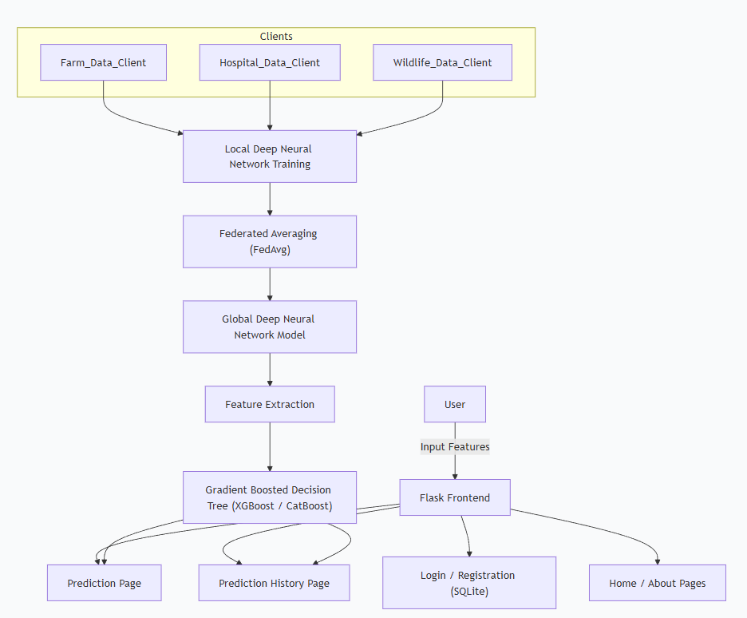

EXISTING SYSTEM:
The existing system for zoonotic disease monitoring relies on a centralized machine learning approach. Data related to animal health, environmental conditions, and human infection cases is collected from multiple sources and stored in a single central repository. Traditional machine learning models such as Random Forest and Gradient Boosting are trained on this centralized dataset to predict zoonotic disease transmission risk. To improve model transparency, explainability techniques like SHAP are used to identify important features influencing predictions. Although this approach provides useful insights, it requires full data sharing from farms, hospitals, and monitoring agencies. Centralized data collection raises concerns related to data privacy, security, and legal restrictions, especially when handling sensitive health and livestock information. In addition, the system struggles to scale efficiently when data sources grow and often faces challenges in handling heterogeneous and incomplete datasets. These limitations reduce the practicality of the existing system for large-scale, distributed zoonotic disease surveillance.

Dis-Advantages of Existing system:
- Requires centralized data storage
- High risk of data privacy violations
- Legal and ethical data-sharing constraints
- Limited scalability with growing data sources
- Vulnerable to data breaches
- Poor handling of distributed data
- Increased communication overhead
- Dependency on complete datasets
- Limited real-world deployment feasibility
- No support for privacy-preserving learning

PROPOSED SYSTEM:
The proposed system introduces a federated machine learning framework for zoonotic disease outbreak prediction to overcome the limitations of centralized approaches. Data remains locally stored at farms, hospitals, and wildlife monitoring systems, where a federated deep neural network is trained independently at each client. Only model parameters are shared with a central server, ensuring privacy preservation. The global model is generated using the Federated Averaging (FedAvg) algorithm. To enhance prediction accuracy and interpretability, the learned features are further processed using gradient-boosted decision tree models such as XGBoost or CatBoost. The system integrates environmental factors, animal population data, human-animal interaction indicators, and epidemiological records. A dataset is used to validate the framework. The final trained model is deployed using a Flask-based web application, providing secure user authentication, outbreak risk prediction, and prediction history management through SQLite. This approach ensures privacy, scalability, and effective outbreak risk assessment.

Advantages of Existing system:
- Preserves data privacy
- Eliminates centralized data storage
- Supports distributed data sources
- Scalable federated architecture
- Handles heterogeneous datasets effectively
- Improves prediction accuracy
- Reduces legal and ethical data-sharing issues
- Enables collaborative learning
- User-friendly Flask deployment
- Suitable for large-scale outbreak monitoring

SOFTWARE REQUIREMENTS
Category | Requirements
Operating System | Windows 10 / Linux
Programming Language | Python 3.8 or higher
Web Framework | Flask
Machine Learning Libraries | Scikit-learn, XGBoost / CatBoost
Federated Learning Support | TensorFlow / PyTorch (for FDNN)
Data Processing | Pandas, NumPy
Database | SQLite
Frontend Technologies | HTML, CSS, JavaScript
Model Serialization | Pickle / Joblib
Development Environment | VS Code / PyCharm

HARDWARE REQUIREMENTS
Category | Requirements
Processor | Intel i5 or equivalent
RAM | Minimum 8 GB
Storage | Minimum 20 GB free space
System Type | 64-bit architecture
GPU (Optional) | NVIDIA GPU for faster training
Network | Standard Internet connection
Input Devices | Keyboard, Mouse
Output Devices | Monitor

ARCHITECTURE
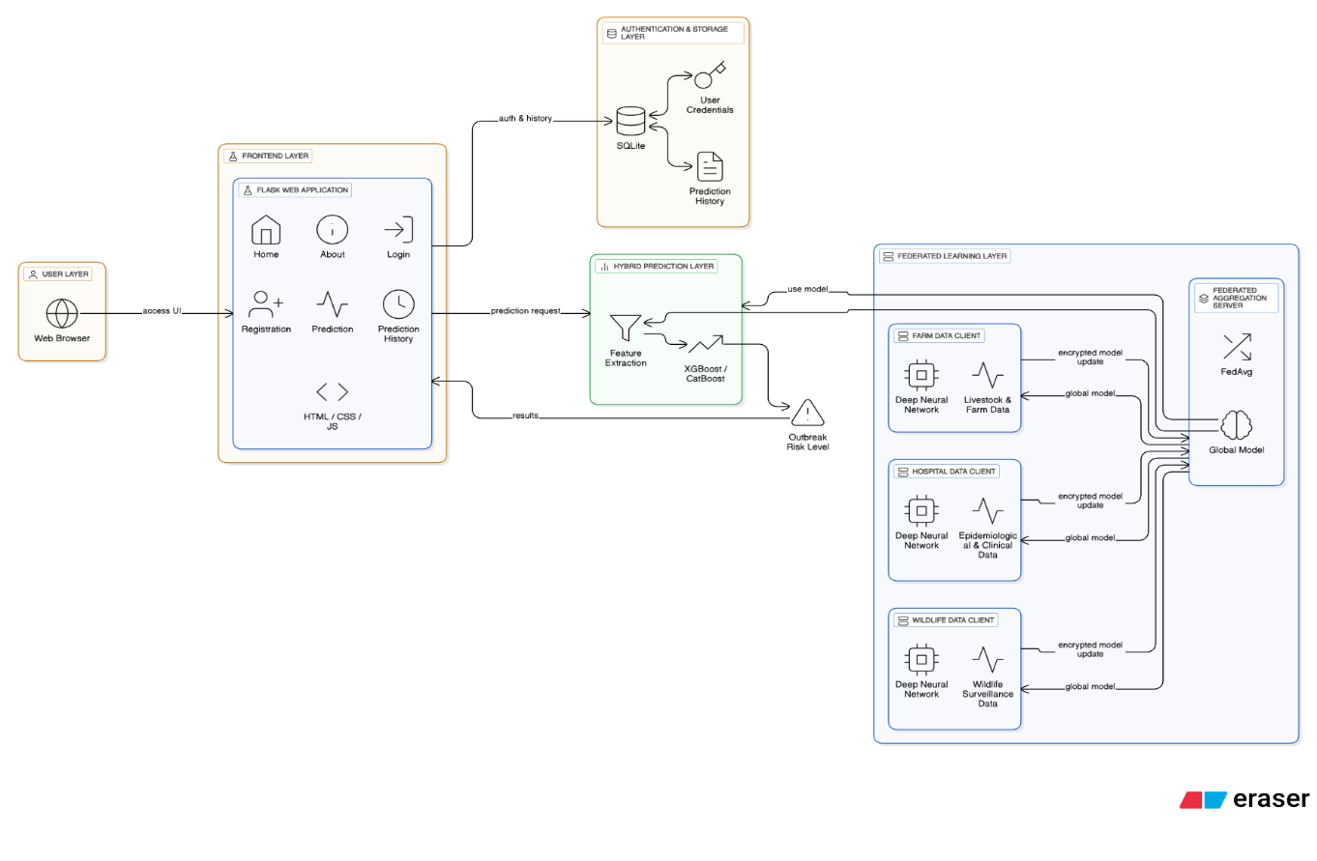

IMPLEMENTATIONS:

- SYSTEM MODULE:

  - Data Collection:
The data collection module is responsible for gathering input data from distributed sources such as farms, hospitals, and wildlife monitoring systems. Each source maintains its own dataset, including animal health records, epidemiological information, and wildlife surveillance data. The data is stored locally at each client to ensure privacy and avoid centralized data sharing. This module supports heterogeneous data formats and ensures that all required features are available for model training. By keeping data at the source, the system maintains data ownership while enabling collaborative learning through federated machine learning.

  - Exploratory Data Analysis (EDA)
The exploratory data analysis module is used to understand the structure and behavior of the collected dataset. Statistical summaries such as mean, minimum, maximum, and distribution of features are analyzed to identify patterns and anomalies. Correlation analysis helps understand relationships between environmental, animal, and epidemiological variables. Visualization techniques like histograms and bar charts are used to inspect class balance of the outbreak risk levels. EDA also helps detect missing values, outliers, and feature ranges. This step ensures that the dataset is consistent, meaningful, and suitable for model training, and it guides decisions during preprocessing and feature selection.
  - Data Preprocessing
The data preprocessing module prepares the dataset for effective model training. Missing values are handled using appropriate statistical methods. Numerical features are scaled to ensure uniformity across different ranges. Categorical and binary features such as wildlife migration indicators are encoded into numerical formats. The target variable, outbreak risk level, is encoded into three classes: low, medium, and high. Data is then split logically across federated clients, ensuring that each client processes only its local data. This module improves data quality, reduces noise, and ensures compatibility with deep learning and tree-based models.

  - Model Building
This module implements the core prediction models. A Federated Deep Neural Network (FDNN) is trained locally at each client using farm, hospital, or wildlife data. The Federated Averaging (FedAvg) algorithm aggregates local model weights to form a global model without sharing raw data. The global model extracts high-level feature representations. These features are then passed to a Gradient Boosted Decision Tree (GBDT) model such as XGBoost or CatBoost. The hybrid approach combines the learning capability of deep neural networks with the interpretability and accuracy of tree-based models, resulting in effective outbreak risk prediction.

  - Model Evaluation
The model evaluation module measures the performance of the trained models. Classification metrics such as accuracy, precision, recall, and F1-score are used to assess prediction quality. A confusion matrix is generated to analyze correct and incorrect classifications across risk levels. Since a synthetic dataset with clear class boundaries is used, the model achieves high accuracy. Evaluation results validate the effectiveness of the federated learning framework and the hybrid modeling approach. This module ensures that the model is reliable, consistent, and suitable for deployment in the web application.

  - Sample predictions
The sample prediction module demonstrates how the trained model produces outbreak risk predictions. Input values such as animal mortality, reported cases, wildlife migration status, and human-animal contact are provided either through test samples or the web interface. These inputs are preprocessed and passed to the trained model. The model outputs a predicted outbreak risk level categorized as low, medium, or high. This module helps verify end-to-end system functionality and ensures that predictions are meaningful and interpretable for users interacting with the application.

  - Model Explainability
The explainability module uses SHAP (SHapley Additive Explanations) to interpret model predictions. SHAP values quantify the contribution of each feature toward the final prediction. This helps identify which factors, such as reported cases, animal mortality, or wildlife migration, influence outbreak risk the most. Visualization of SHAP values improves transparency and trust in the system. This module supports decision-making by providing insights into feature importance and model behavior, making the system more understandable for health authorities and researchers.

- USER MODULES
  - Home Page
The Home module serves as the main entry point of the application. It provides an overview of the zoonotic disease outbreak prediction system and highlights the purpose and importance of early risk detection. The page briefly introduces federated learning and explains how the system protects data privacy while predicting outbreak risk. It also guides users to navigate to other sections such as About, Login, and Registration. The Home module is accessible to all users without authentication and acts as an informational dashboard that improves user understanding and system usability.

  - About Page
The About module explains the background and objectives of the project. It describes zoonotic diseases, their impact, and the need for early outbreak prediction. The module also explains the system architecture, including federated learning, deep neural networks, FedAvg aggregation, and gradient-boosted decision trees. Additionally, it provides information about the dataset, prediction workflow, and technologies used such as Flask and SQLite. This module helps users understand how the system works and the benefits of using a privacy-preserving learning approach.

  - Register
The Register module allows new users to create an account in the system. Users provide basic details such as username, email address, and password. The entered information is validated and securely stored in a SQLite database. This module ensures that only authorized users can access prediction-related features. Registration helps maintain user identity and enables personalized access to prediction history. The module improves system security and allows controlled usage of the application.

  - Login
The Login module authenticates registered users by verifying their credentials against the SQLite database. Only valid users are granted access to prediction and history modules. This module ensures secure access and prevents unauthorized usage of the system. After successful login, users can interact with the outbreak prediction features. Session management is used to maintain user state during application usage. The Login module plays a key role in ensuring data security and personalized user experience.

  - Prediction
The Prediction module allows authenticated users to input required parameters related to farm, hospital, and wildlife data. These inputs are processed and passed to the trained machine learning model deployed in the Flask backend. The system predicts the zoonotic outbreak risk level as low, medium, or high. The prediction result is displayed to the user in a clear format. This module represents the core functionality of the application and demonstrates the practical use of the trained model.

  - History
The History module stores and displays previous predictions made by the user. Each record includes input values, predicted outbreak risk level, and timestamp. The data is retrieved from the SQLite database and shown in a structured format. This module allows users to review earlier predictions and understand trends in risk levels. It supports transparency and enhances user engagement by maintaining a record of past interactions with the system.

  - Logout
The Logout module allows users to securely exit the application. When a user logs out, the active session is terminated, and access to protected pages such as prediction and history is restricted. This module ensures that user data remains secure and prevents unauthorized access after logout. The user is redirected to the Home or Login page upon successful logout. The Logout module is essential for maintaining session security and protecting user information.

